Lesson 02

Overview
In this worksheet, we review some basic JavaScript concepts and walkthrough the PetCareApp.
Before you attempt the questions in this worksheet, you should go through the respective topics in your notes:
Worksheet | Notes
Section A | Web Application Revision
Section B | PetCareApp Walkthrough
Section C | Submissions

Materials
There is one problem statement for each learning package. A learning package is made up of a few lessons. In each lesson in the learning package, you will generally find a set of slides that serves as your notes, and a worksheet. As you go through the day with your lecturer, there will be activities for you to work on. Some activities are meant to help you take notes, while others are for you to delve deeper into the topics.
These activities will be mapped in both the slides and worksheet. You should put your answers in the worksheet. Below are some icons to guide you on what an activity will require you to do.
 Answer some questions on your own as you watch a video or listen to your lecturer.
 Team discussions
 This is a lecturer-led activity. Your lecturer will guide you through an activity step-by-step. Pay attention!

Do seek your lecturer’s advice when in doubt

Section A – Web Application Revision
Exercise 1
- In the Revision folder, create a file named ex01.js. In ex01.js, type the following code below to calculate the pet grooming fee.
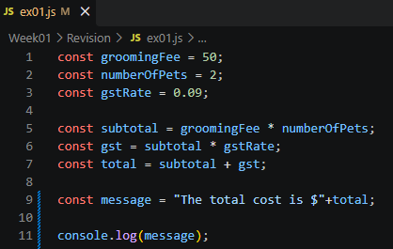
- Ensure that you are in the right folder in the console(You should be in the Revision folder.)
- Run the JS file: node ex01.js
- What is the output?
The total cost is $109

- What are the datatypes of the variables?
Variable | Data Type
groomingFee | Number
numberofPets | Number
gstRate | Number
subtotal | Number
gst | Number
message | String

- What is the difference between const and let?
Reassigning a constant variable will result in a runtime error. Whereas a let variable can be updated later on in the code.

Exercise 2
In the Revision folder, create a file named ex02.js. In ex02.js, implement the logic shown in the table below to process a grooming fee payment status. (Use conditional logic to decide what users see.)

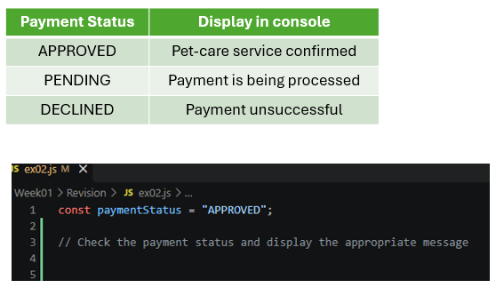

if (paymentStatus === "APPROVED") {
console.log("Pet-care service confirmed");
} else if (paymentStatus === "PENDING") {
console.log("Payment is being processed");
} else if (paymentStatus === "DECLINED") {
console.log("Payment unsuccessful");
}

Exercise 3
In the Revision folder, create a file named ex03.js.
Given the payments array as shown:
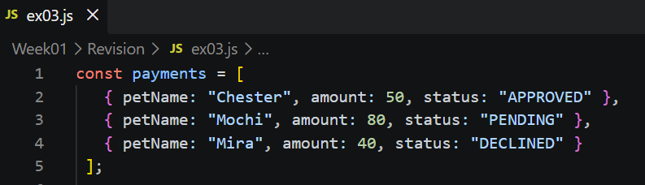

In ex03.js,
- Write the code to display Mochi’s payment status
- Use a loop to display the payment details for each pet.
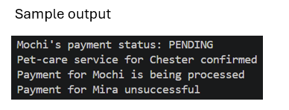
- console.log(`${payments[1].petName}'s payment status: ${payments[1].status}`);

for (let i = 0; i < payments.length; i++) {
const p = payments[i];
if (p.status === "APPROVED") {
console.log(`Pet-care service for ${p.petName} confirmed`);
} else if (p.status === "PENDING") {
console.log(`Payment for ${p.petName} is being processed`);
} else if (p.status === "DECLINED") {
console.log(`Payment for ${p.petName} unsuccessful`);
}
}

Section B – PetCareApp Walkthrough
Exercise 4
Given the page shown, trace the request.
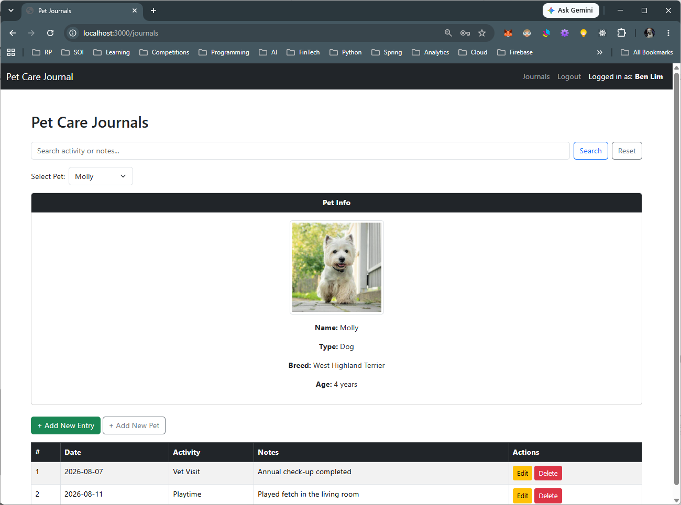

Step | Question | Answer
Browser action | Which link did you click? What URL was requested? | Clicked the Journals link  http://localhost:3000/journals
Route handler | What HTTP method and route pattern handle this request? | Get method and /journal route
Input | What value does the handler read, and where does it come from—for example, req.params? | Read user session data and query parameters
Database operation | Which SQL query runs? Which table and record does it access? | Queries database tables to retrive pet profiles and journals
View | Which EJS template is rendered? What data is passed into it? | Journals template is rendered and data includes user information, pet list, selected pet details, and the list of journal entries
Output | Where does the template display that data? | Displays the pet profile information card and the table of journal entries at the bottom of the page.

Exercise 5
Given the page shown, trace the request.
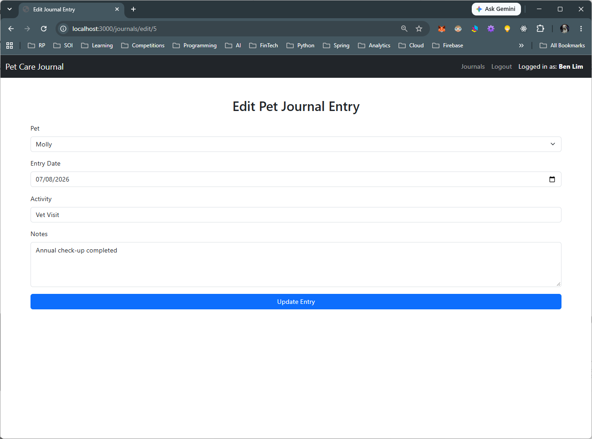

Step | Question | Answer
Browser action | Which link did you click? What URL was requested? | The update link was clicked and this url was requested(http://localhost:3000/journals/edit/5)
Route handler | What HTTP method and route pattern handle this request? | POST method
Input | What value does the handler read, and where does it come from—for example, req.params? | Reads req.params.id to identify the record, and req.body to retrieve the updated form inputs
Database operation | Which SQL query runs? Which table and record does it access? | Runs an UPDATE SQL query on the journal entries table to modify the specific record where id = 5
View | Which EJS template is rendered? What data is passed into it? | the application redirects (e.g., res.redirect('/journals') instead of rendering.
Output | Where does the template display that data? | The user is redirected back to the Pet Care Journals main page (http://localhost:3000/journals), displaying the updated journal entry details in the list.

Section C – Submissions
Deliverables for today
- Worksheet (Individual)
- Upload your deliverables to POLITEMALL even if it is incomplete before the next session.
- You can resubmit by 2359 if there are updates.

